***http://documentation.statsoft.com/STATISTICAHelp/Query/Images/QUERY.GIF*What is the difference between ODBC and OLE DB?**

The differences between these two data access protocols are technical, but in the most general terms, [OLE DB](http://documentation.statsoft.com/STATISTICAHelp.aspx?path=Glossary/GlossaryTwo/O/OLEDB) is newer, more advanced, and compatible with a wider selection of database technologies. In addition, OLE DB is more general, in that it includes the [ODBC](http://documentation.statsoft.com/STATISTICAHelp.aspx?path=Glossary/GlossaryTwo/O/ODBC) functionality.

Technically speaking, ODBC (Open Database Connectivity) is designed to provide access primarily to SQL data in a multi-platform environment. OLE DB (Object Linking and Embedding Database) is designed to provide access to all types of data in an OLE Component Object Model (COM) environment. OLE DB includes the SQL functionality defined in ODBC but also defines interfaces suitable for gaining access to data other than SQL data.

A query generated via ODBC is functionally similar to a query generated by OLE DB. However, be aware that if you generate a query (via [*STATISTICA*Query](http://documentation.statsoft.com/STATISTICAHelp.aspx?path=main/Indices/WorkingwithSTATISTICAQuery_HIndex)) using an ODBC connection, *STATISTICA* uses OLE DB to connect to the ODBC connection. Because there is an intermediate connection, ODBC queries may be slower than OLE DB queries.

***n one bite ::***we commonly used functionality in qv while connect to db. here is the issue we know all of us use OLEDB why it is Preferable here i go with simple words...  
  
  
ODBC : we can use this and access only relational database's such as oracle,mysql, mssql like,,  
using we can't access old databases.  
  
OLEDB : it's combination of Relational and non relational database's  
it means the databases like XML,Mongo DB ,, (not only these)  
  
Here look at Image for clear expo   [Image  source](http://books.google.ca/books?id=JTKX7OUqCEMC&lpg=PP1&dq=contact%20jason%20roff%20activex%20data%20objects&pg=PA12#v=onepage&q=contact%20jason%20roff%20activex%20data%20objects&f=false)

[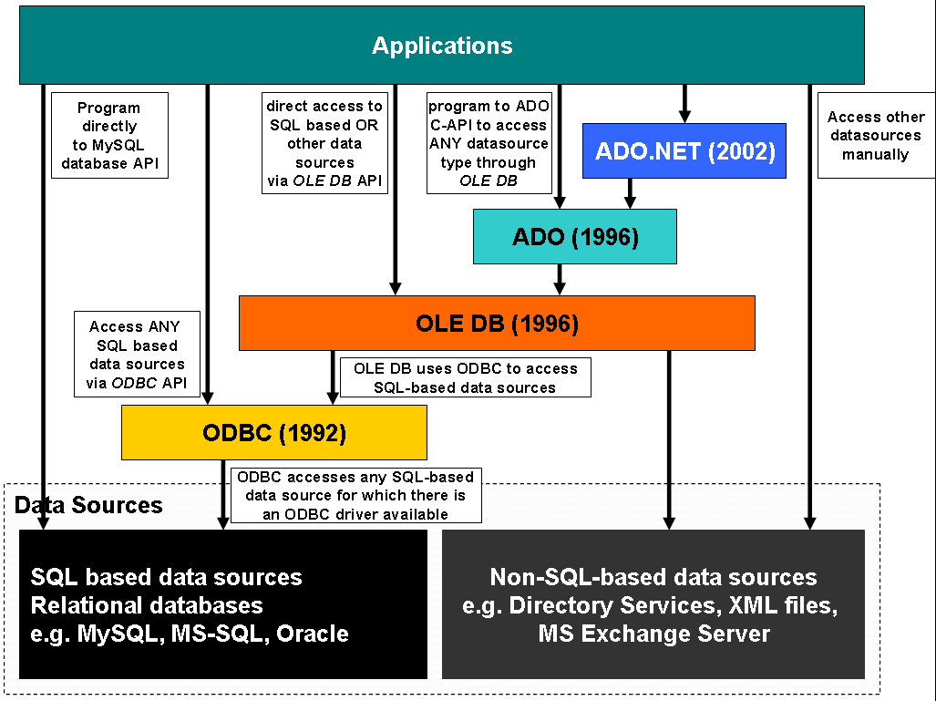](http://1.bp.blogspot.com/-J0Ee5_y1JZ8/VGYT_dJvBhI/AAAAAAAAAAw/PKqvxcSXFFc/s1600/db-full-diagram.png)

* ODBC provides access only to relational databases
* OLE DB provides the following features
  + Access to data regardless of its format or location
  + Full access to ODBC data sources and ODBC drivers

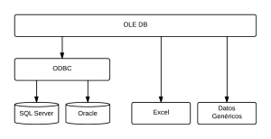

<https://qlikshare.com/category/qlikview-video-tutorials/> 🡪videos from here